

**Name**: Mirza Hammad Tariq

**Class**: BS-IT 6th (Morning)

**Roll** **No**: ITS-11065

**Subject**: Web Technologies

**Instructor**: Mr. Ahsan Arif

**Date**: Oct 4th, 2024

**Lab No**: 4

**Lab Task 1**

Build a Login form for NUML Student Information Management System

**Activity**

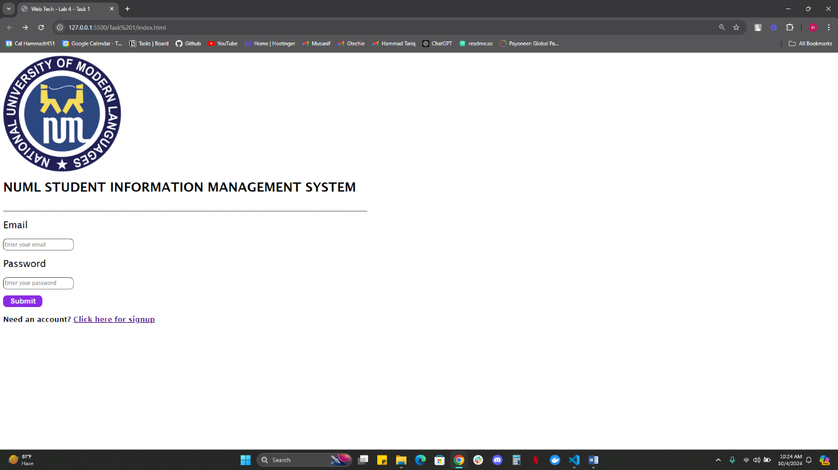

Figure 1

**Lab Task 2**

Build a Sign up form for NUML Student Information Management System

**Activity**

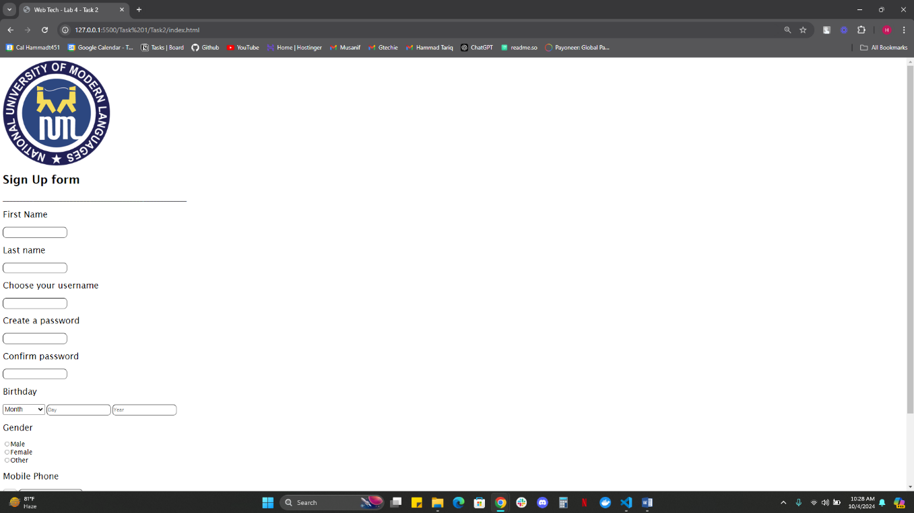

Figure 2